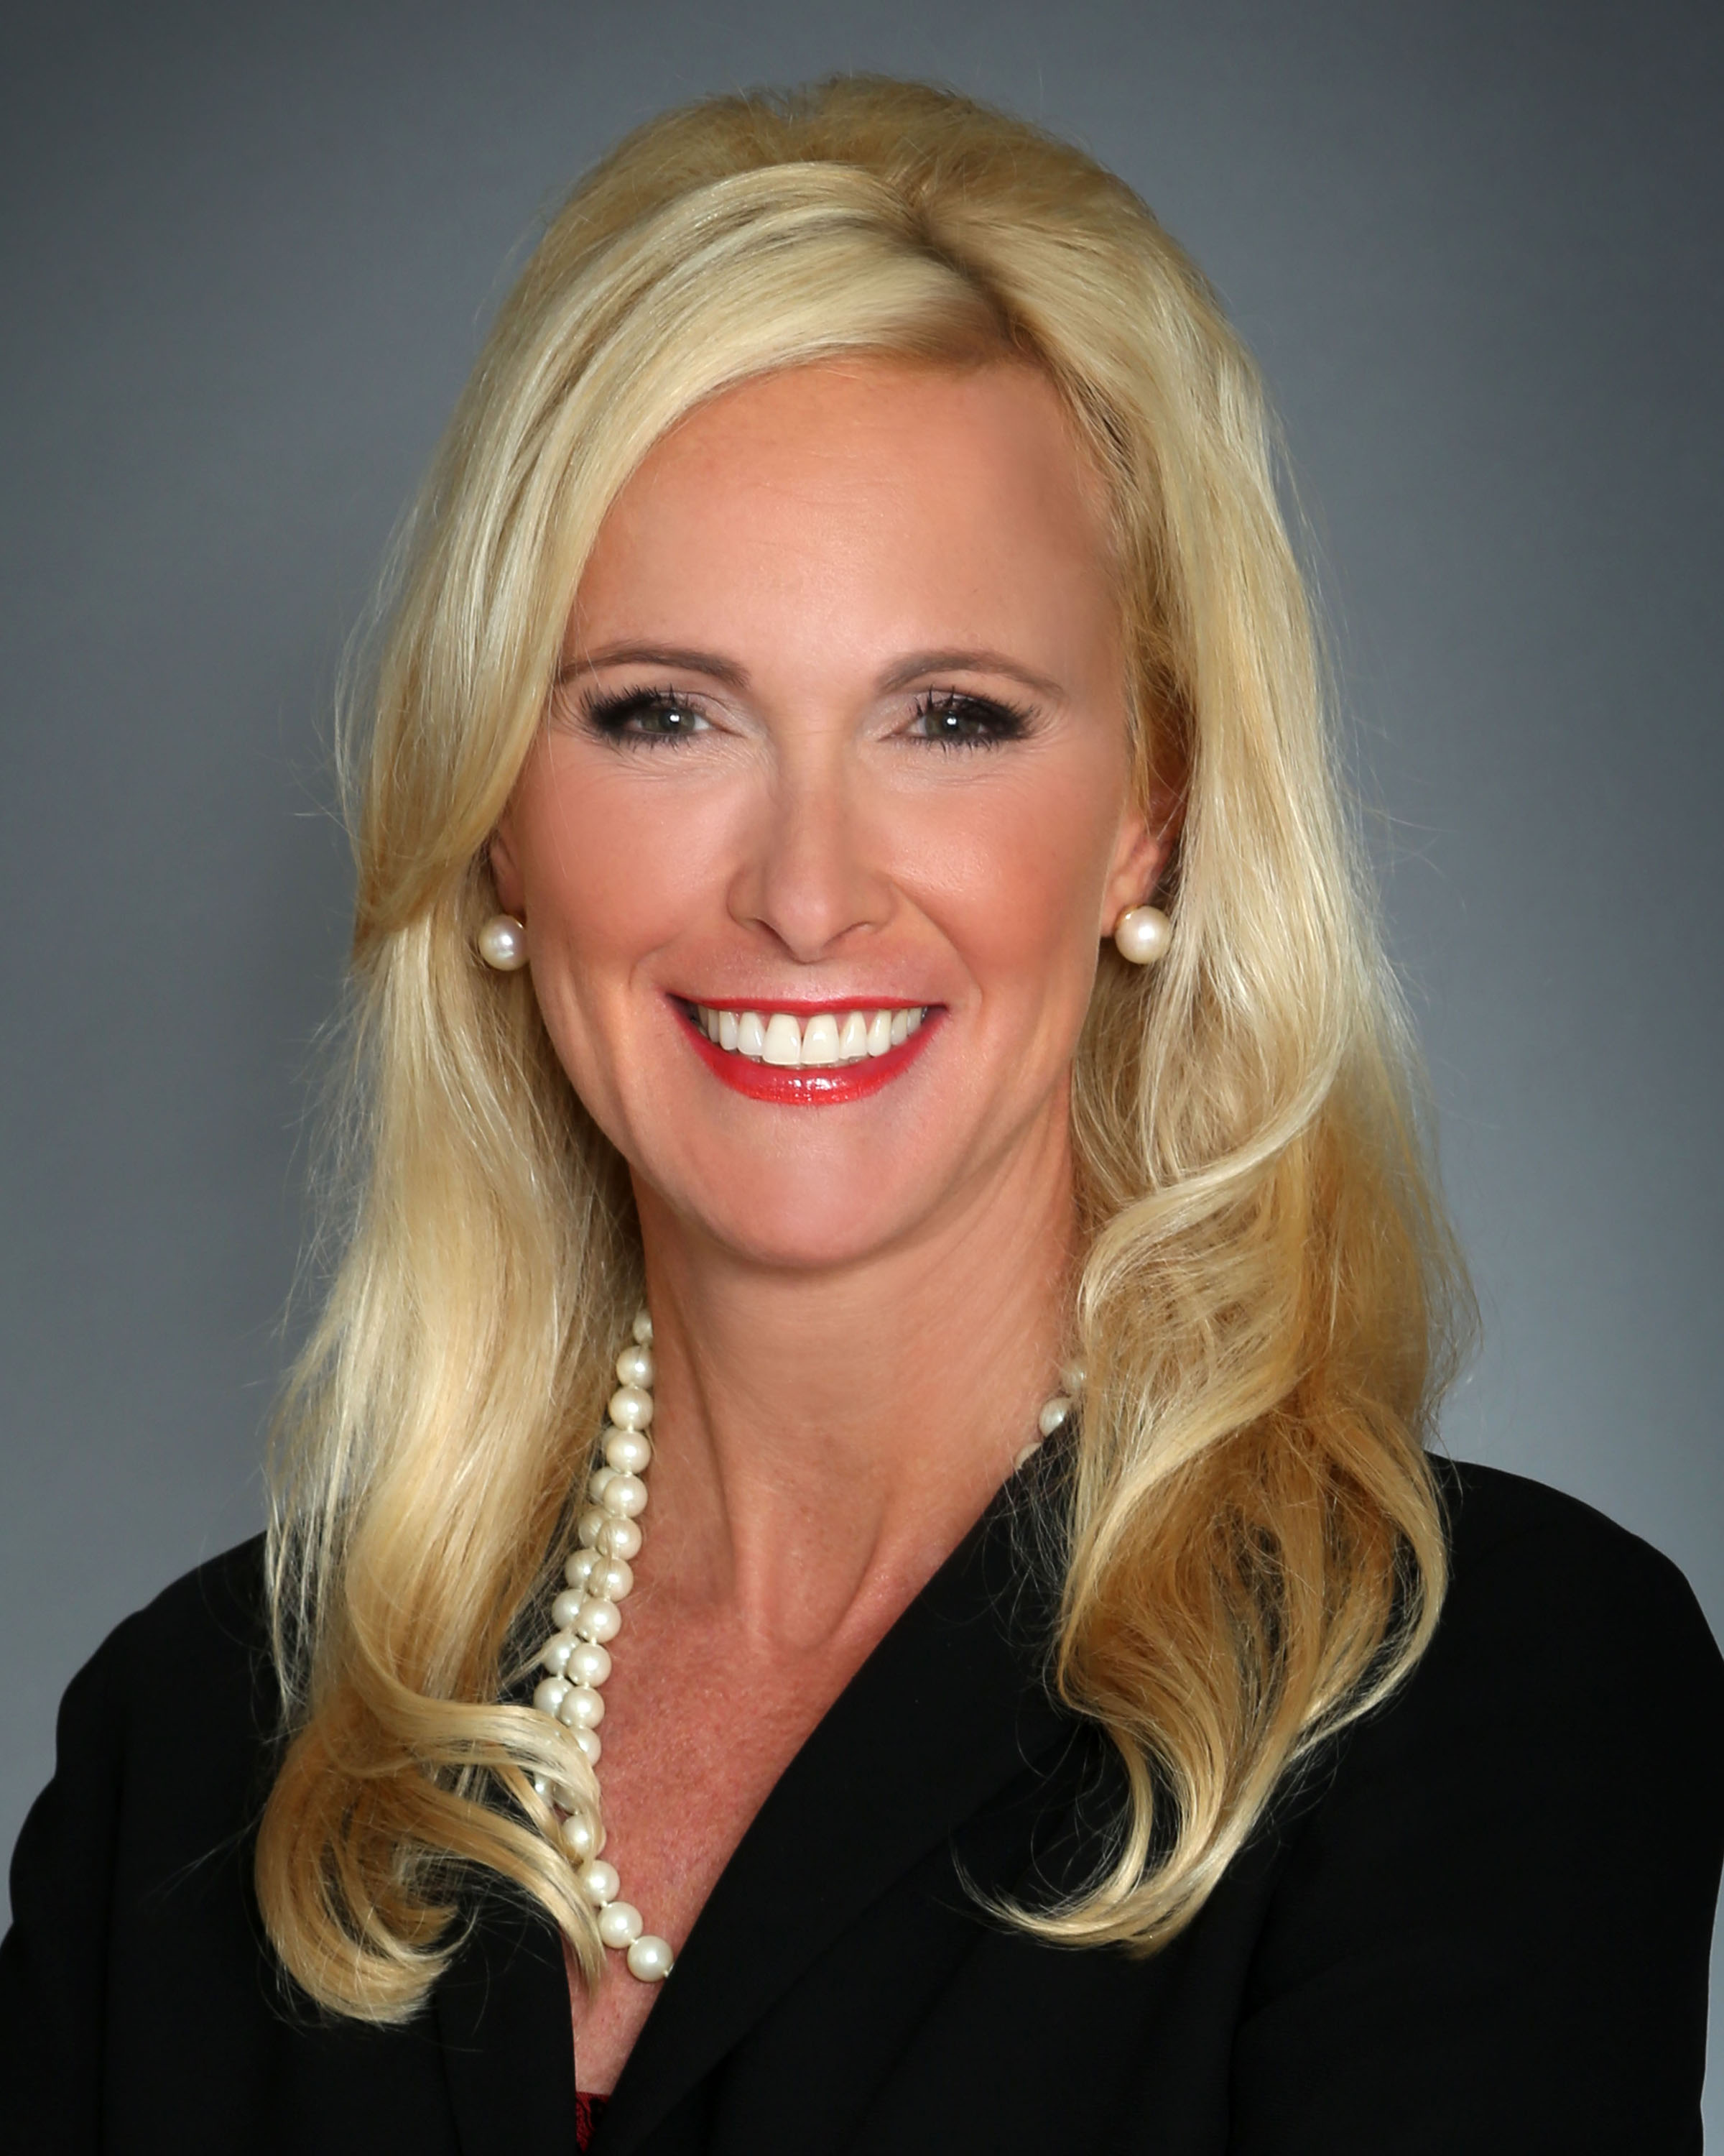
Christine R. Spray
Christine Spray is a nationally recognized business development keynote speaker, best-selling author two times, consultant, trainer, coach and Professional EOS Implementer. Spray serves as a CEO and business advisor with a passion for helping people and companies grow.

Best-Selling Author with Steve Forbes
SuccessOnomics-Doing Business in Today’s Economy
Best-Selling Lists and Rankings: #1 Direct Marketing, #4 Marketing, #5 Marketing & Sales, #11 Entrepreneurship, #12 Small Business and Entrepreneurship, and #91 Business & Money

Best-Selling Author with Brian Tracy
Transform-Your Life, Business & Health
Best-Selling Lists and Rankings: #6 Direct Marketing, #13 Marketing for Small Business

Founder & President
Spray enjoys giving back to the community where she serves and has served in the following roles:
- Founder and President, National Business Development Association
- Former Chair, Women Energy Network’s Advisory Council and Executive Group
- Former Board Member, Women Energy Network
- Former Committee Chair, Emerging Women Leaders Greater Houston Partnership
- Former Committee Chair, University of Houston Alumni
- Former President, Association for Accounting Marketing
- Former Co-Chair, Kay Bailey Hutchison Texas Governor Race
- Former Nominating Chair, Leadership Council American Lung Association
- Former Board Member, Houston Health Charities of Texas
- Former Board Member, Houston Strategic Forum
- Former Board Member, MIT Enterprise Forum
- Former Board Member, YMCA Camping Services
- Former Delegate, American Society of Women Accountants
- Former Chairman, Small Business Committee GSWCC
- Former Co-Chair, Shaker Committee GSWCC

Strategic Catalyst, Inc.
Spray launched Strategic Catalyst, Inc. after working in public accounting and industry in senior leadership roles with start-up, restructuring and growth responsibilities. She recognized that by aligning business goals with marketing, human resource and business development strategies, organizations could leverage new business opportunities for far greater results. With more than 20 years of experience, Spray has created proven programs for management in the area of new business strategy by implementing Revenue Growth Assessments, Business Development Programs, Strategic Business Development Plans, and Accountability Models. Spray is a graduate of Coach University’s Two Year Program and EOS Worldwide.

Founder & President
National Business Development Association
Spray launched the National Business Development Association (NBDA) to fill the need for a national trade association to provide best practices to individuals whose primary responsibility is generating business for their organization. NBDA provides a vibrant learning community where members can stay on top of industry trends and continually hone their skills through targeted professional development. Members of NBDA strongly believe in order to be a successful business development professional, you must focus on others and their needs before focusing on yourself. You will find this philosophy at the center of everything that is taught at the NBDA.

Chair & National Speaker
Vistage International
Spray has been recognized for the following:
- Houston Hero Award, 25th Annual SCA Houston’s Entrepreneurial Independence & Leadership
- Chair Excellence Award, Vistage International
- 50 Most Influential Women, Houston Women Magazine
- Keynote Speaker and Contributing Author, Steve Forbes
- Rookie of the Year, Vistage International
- Entrepreneur of the Year, Houston Technology Center
- Top Ambassador, Greater Houston Partnership
- Lifetime Member, Greater Houston Partnership
- Mover & Shaker, Greater Southwest Houston

Spray serves as Chair and National Speaker for Vistage International, the world’s leading chief executive organization; its affiliates have more than 16,000 members in 16 countries. In her leadership role, she leads C-level executive discussions to help companies implement more efficient processes and programs that reduce costs, increase profitability and foster enhanced growth.

